Email Sending

📬 How Email Sending Works in the Backend (Step-by-Step)

1. 📝 Email is Composed by Your App
# Source: Chatgpt (GPT-5-Mini) at [1/21/2026]
Your PHP script (or app) prepares:
- Recipient (To)
- Subject
- Message body (text or HTML)
- Headers (From, Reply-To, MIME type, etc.)
Example from PHP:
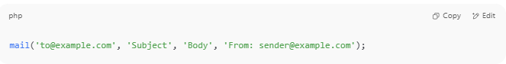
mail('to@example.com', 'Subject', 'Body', 'From: sender@example.com');

2. 📡 App Connects to a Mail Server (SMTP Server)
# Source: Chatgpt (GPT-5-Mini) at [1/21/2026]
- The server could be:
  - Gmail SMTP (smtp.gmail.com)
  - SendGrid (smtp.sendgrid.net)
  - Your own company server (mail.yourdomain.com)
- This is usually done via SMTP protocol, over ports:
  - 587 (TLS, recommended)
  - 465 (SSL)
  - 25 (basic SMTP, often blocked)

3. 🔐 Authentication Happens (If SMTP Used)
# Source: Chatgpt (GPT-5-Mini) at [1/21/2026]
Your app provides:
- SMTP username (usually your email)
- SMTP password (often an app password)
- Then the server says: ✅ OK or ❌ Auth failed
⚠️ PHP's mail() function skips this step — and that’s why it's often blocked!

4. 📤 Mail Server Accepts the Message
# Source: Chatgpt (GPT-5-Mini) at [1/21/2026]
If authentication is successful:
- The message is handed over to the SMTP server
- The server queues the email for delivery

5. 🚚 Mail Server Delivers Email to Recipient’s Server
# Source: Chatgpt (GPT-5-Mini) at [1/21/2026]
The SMTP server:
- Looks up the recipient's domain via DNS (MX record)
- Connects to the recipient's mail server
- Sends the email to that server

6. 📥 Recipient Server Stores It in Inbox (IMAP/POP)
# Source: Chatgpt (GPT-5-Mini) at [1/21/2026]
- The email is stored in their mailbox
- When the user opens Gmail, Outlook, or Yahoo → they see your email

📌 Diagram Overview
# Source: Chatgpt (GPT-5-Mini) at [1/21/2026]
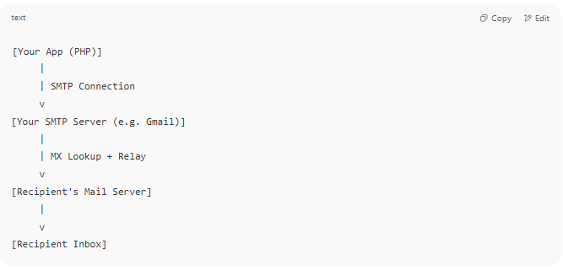
[Your App (PHP)]
|
| SMTP Connection
v
[Your SMTP Server (e.g. Gmail)]
|
| MX Lookup + Relay
v
[Recipient's Mail Server]
|
v
[Recipient Inbox]

🔍 What Happens in PHP?
# Source: Chatgpt (GPT-5-Mini) at [1/21/2026]
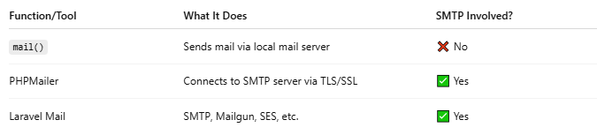
Function/Tool | What It Does | SMTP Involved?
mail() | Sends mail via local mail server | ❌ No
PHPMailer | Connects to SMTP server via TLS/SSL | ✅ Yes
Laravel Mail | SMTP, Mailgun, SES, etc. | ✅ Yes

🧠 Summary
# Source: Chatgpt (GPT-5-Mini) at [1/21/2026]
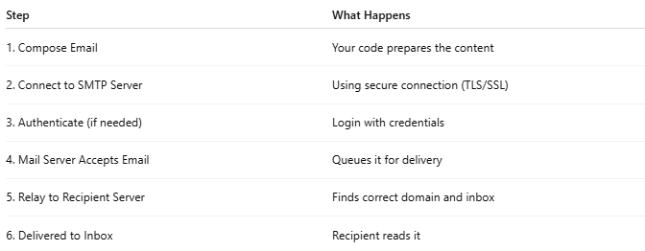
Step | What Happens
1. Compose Email | Your code prepares the content
2. Connect to SMTP Server | Using secure connection (TLS/SSL)
3. Authenticate (if needed) | Login with credentials
4. Mail Server Accepts Email | Queues it for delivery
5. Relay to Recipient Server | Finds correct domain and inbox
6. Delivered to Inbox | Recipient reads it

📍 When Your Project Sends Email via an SMTP Server — What Does Localhost Do?
# Source: Chatgpt (GPT-5-Mini) at [1/21/2026]
👉 In that case: Localhost (your local WAMP/XAMPP server) just acts as the application host.
It does NOT send the email itself. It just runs your code that connects to an external mail server (SMTP) to send the email.

🔁 What Really Happens When Using PHPMailer + SMTP (on Localhost)
# Source: Chatgpt (GPT-5-Mini) at [1/21/2026]
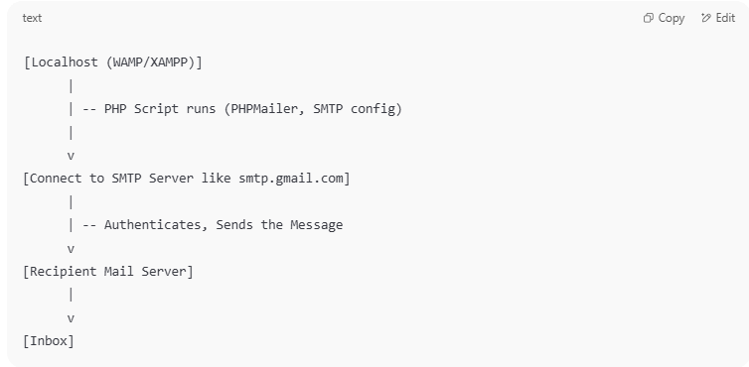

[Localhost (WAMP/XAMPP)]
|
| -- PHP Script runs (PHPMailer, SMTP config)
|
v
[Connect to SMTP Server like smtp.gmail.com]
|
| -- Authenticates, Sends the Message
v
[Recipient Mail Server]
|
v
[Inbox]

✅ So Localhost's Role is:
# Source: Chatgpt (GPT-5-Mini) at [1/21/2026]

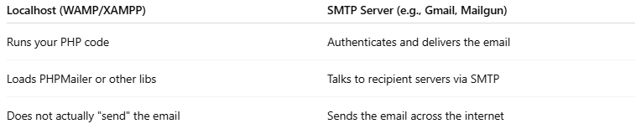
Localhost (WAMP/XAMPP) | SMTP Server (e.g., Gmail, Mailgun)
Runs your PHP code | Authenticates and delivers the email
Loads PHPMailer or other libs | Talks to recipient servers via SMTP
Does not actually "send" the email | Sends the email across the internet

🛠️ Example
# Source: Chatgpt (GPT-5-Mini) at [1/21/2026]
You're developing on localhost with this code:
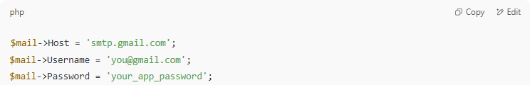
$mail->Host = 'smtp.gmail.com';
$mail->Username = 'you@gmail.com';
$mail->Password = 'your_app_password';

Here’s what happens:
- Your PHP code runs on localhost
- It connects to smtp.gmail.com
- Gmail's servers actually send the email
- Your localhost server is just the client

🔐 Why Use SMTP Instead of PHP mail()?
# Source: Chatgpt (GPT-5-Mini) at [1/21/2026]
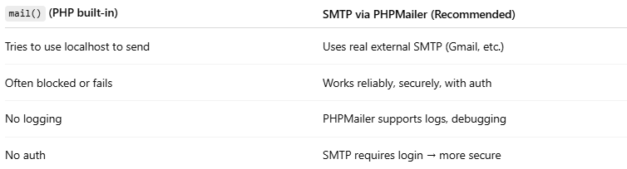

mail() (PHP built-in) | SMTP via PHPMailer (Recommended)
Tries to use localhost to send | Uses real external SMTP (Gmail, etc.)
Often blocked or fails | Works reliably, securely, with auth
No logging | PHPMailer supports logs, debugging
No auth | SMTP requires login → more secure

✅ Summary
# Source: Chatgpt (GPT-5-Mini) at [1/21/2026]
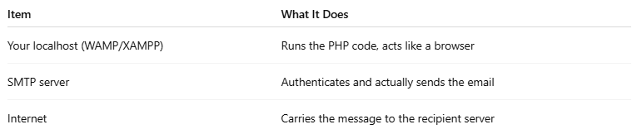

Item | What It Does
Your localhost (WAMP/XAMPP) | Runs the PHP code, acts like a browser
SMTP server | Authenticates and actually sends the email
Internet | Carries the message to the recipient server

Would you like a diagram showing SMTP vs mail() visually, or a demo PHPMailer script ready to test on your localhost?

